A. Reactivity series and displacement reactions as redox reactions
- Three metals, X, Y and Z were put into water. The reactions are shown below:
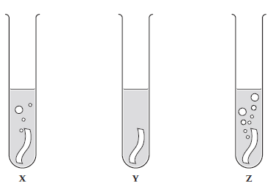
a) Use the diagrams to put metals X, Y and Z in order of reactivity, starting with the most reactive. (1)

b) When a metal reacts with water, it produces hydrogen gas and a metal hydroxide. Describe how you can test for the gas. (2)

c) Give two variables that should be controlled in this investigation. (2)

- A student carried out some displacement reactions using three metals and three sulfate solutions.
The results are shown in the table below:

 | Iron sulfate  (FeSO₄) | Copper sulfate  (CuSO₄) | Magnesium sulfate (MgSO₄)
Iron (Fe) |  | ✓ | ✗
Copper (Cu) | ✗ |  | ✗
Magnesium (Mg) | ✓ | ✓

- i) Explain what is observed when iron reacts with copper sulfate. (2)

ii) HT: Write an ionic equation for the reaction between iron and copper sulfate solution. (2)

- Explain why there is no observation between copper and iron sulfate. (2)

- i) Explain what is observed when magnesium reacts with iron sulfate. (2)

ii) HT: Write a half equation to show the reduction of iron ions (Fe²⁺) when magnesium reacts with iron sulfate. Use the half equation to explain why Fe²⁺ ions are reduced.

B. Extracting metals: Metal ores; oxidation and reduction; methods of extraction and biological methods of extraction
1. Extended response question:

Describe how phytomining and bioleaching are now being used to extract copper and why these methods are being used. (6)

- Explain how the position of a metal in the reactivity series is linked to the method used to extract a metal from its ore. (4)

- Explain the terms oxidation and reduction in terms of electrons and in terms of oxygen. (4)

- When metals are extracted from their ores do they undergo oxidation or reduction? Explain your answer. (2)

- How is a metal’s relative position in the reactivity series linked to oxidation? (3)

C. Extracting metals: Recycling metals and life-cycle assessment
1. In the given stages below, compare the life cycle assessments for a plastic and a paper bag used for shopping. The first stage has been completed for you.

Extracting and processing raw materials
Plastic bag – crude oil needs to be extracted from the Earth which requires energy and may cause pollution.
Paper bag – trees need to be cut down and removed which causes destruction of forests and loss of habitats but can be sustainable.

Manufacturing and packaging (2)

Use and operation during its lifetime (2)

Disposal at the end of its useful life (2)

- Evaluate the advantages of recycling metals. (4)

- Describe some potential issues associated with carrying out life time assessments. (4)

D. Reversible reactions, dynamic equilibrium and the Haber process
- Ammonia can be used to produce nitrogen-based fertilisers. It is manufactured on an industrial scale using the Haber process. Explain how ammonia is produced using the Haber process. You should include the following in your response:
  - an equation
  - a source for each raw material
  - the reaction conditions.
(6)

- The following graph outlines the impact of reaction conditions on the percentage yield of ammonia from the Haber process. Describe the conditions which give the highest yield and explain why there is a compromise on these conditions in industry [4].
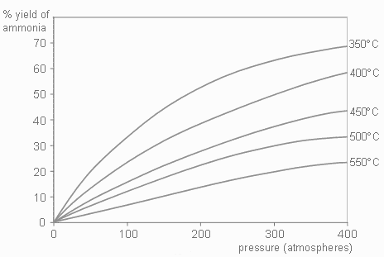

- Explain what is meant by the term dynamic equilibrium. (1)

- Other than changing the pressure, for the reaction below describe and explain how you would produce more ammonia NH₃ (2)

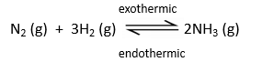

- For the reaction below, 135 kJ of energy is put in to make anhydrous copper sulfate. How much energy will be released if the same amount of water is added to the anhydrous copper sulfate as was removed in the forward reaction? Explain your answer. (2)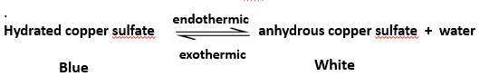

E. Factors affecting dynamic equilibria (HT)
- The following reversible reaction is used in the manufacture of sulfuric acid. The forward reaction is exothermic.
2SO₂ + O₂ 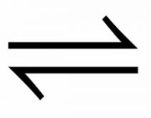 2SO₃
Describe the conditions which would favour the forward reaction by changing the position of dynamic equilibrium. Explain the reasons for your choice. (6)

- A student is investigating the following reaction


Describe what would happen if the student increased the concentration of reactants, then the concentration of products and explain why you think this. (6)

- A reaction is at equilibrium. The reactants are iodine gas I₂ and hydrogen gas H₂; the product is hydrogen iodide gas HI. When the temperature of the system is increased, more iodine and hydrogen are produced.
Write the balanced symbol equation for this reaction and include the directions of the endothermic and exothermic reactions and the state symbols (4).

- Explain what would happen in the following equilibrium reaction if we increased the pressure. (3)

N₂ (g) + 3H₂ (g)  2NH₃ (g)

